#
# 20181106
# Very often, after login I can see Disconnected adapter in Dell SupportAssist Enterprise.
# https://vm-dell-ome01t.tcsbank.ru:5700/SupportAssist/resx/index.html#/

# I see follow explanation, why the Adapter not in working state.
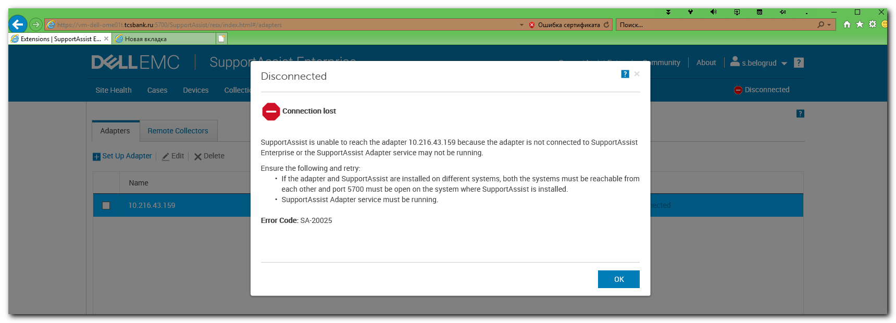

# Here I simple test, what credentials is used to for this Adapter.
# Everything looks good.
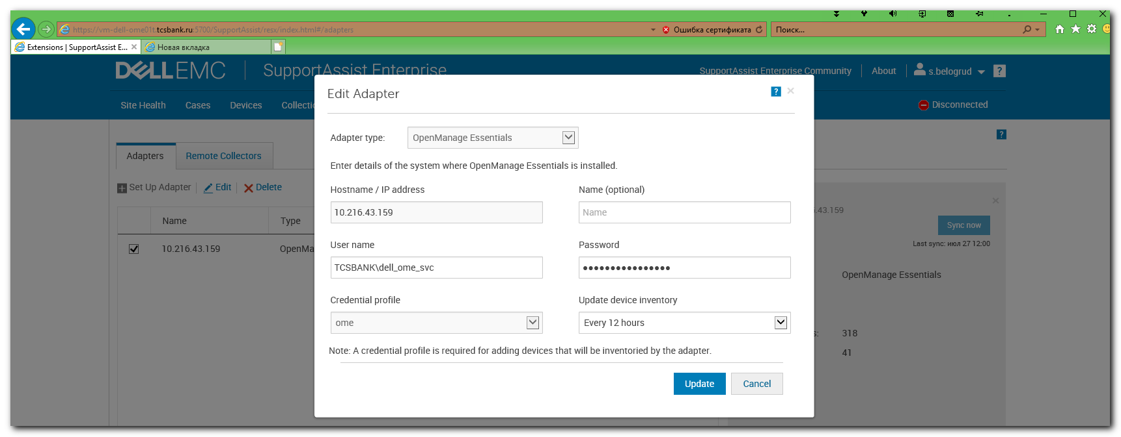

# To fix trouble, I wanted to test - is the Service working correctly or no?
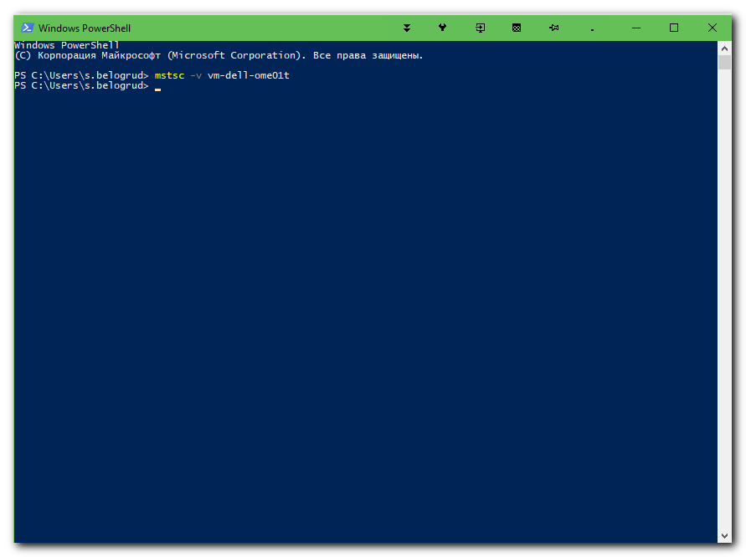

# Here is the reason, why the Adapter is not working.
# It’s need to start service “Dell EMC SupportAssist Enterprise OME Adapter”.
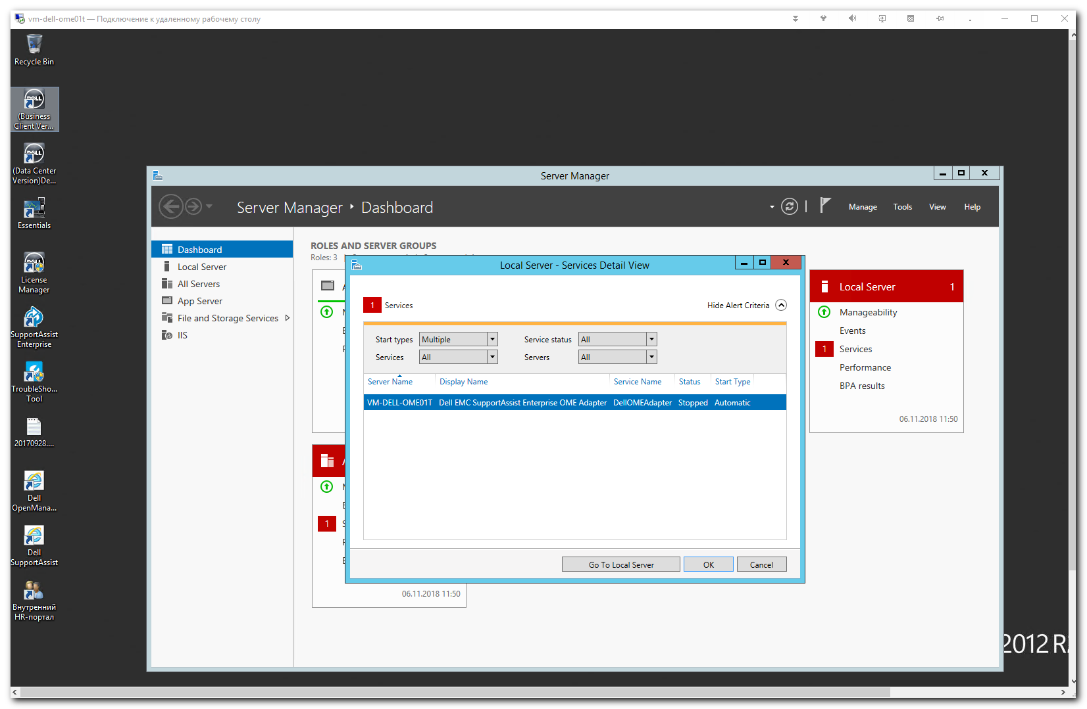

# After service was started again.
# It takes a minute or less.
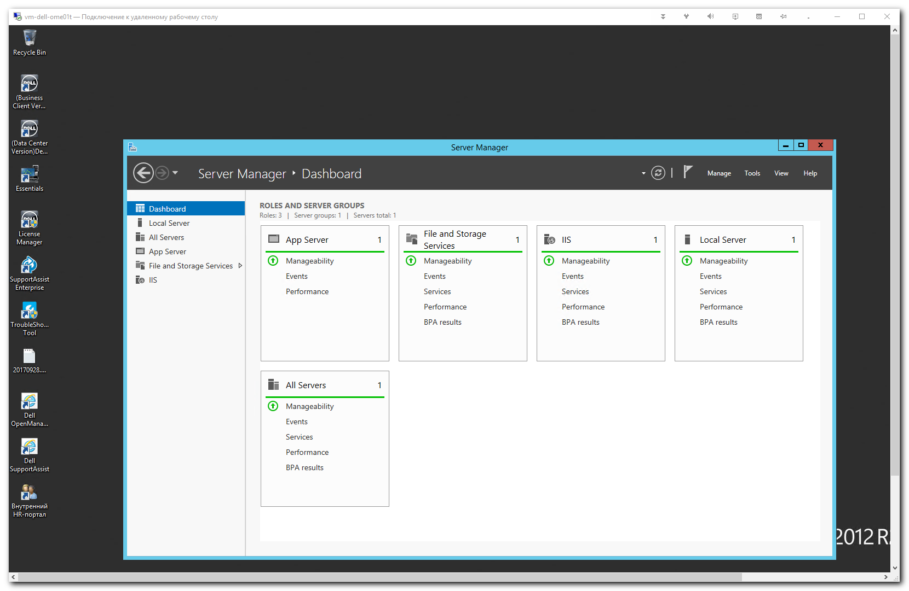

# I tried to do Sync the Adapter and the Adapter became to their status Connected.
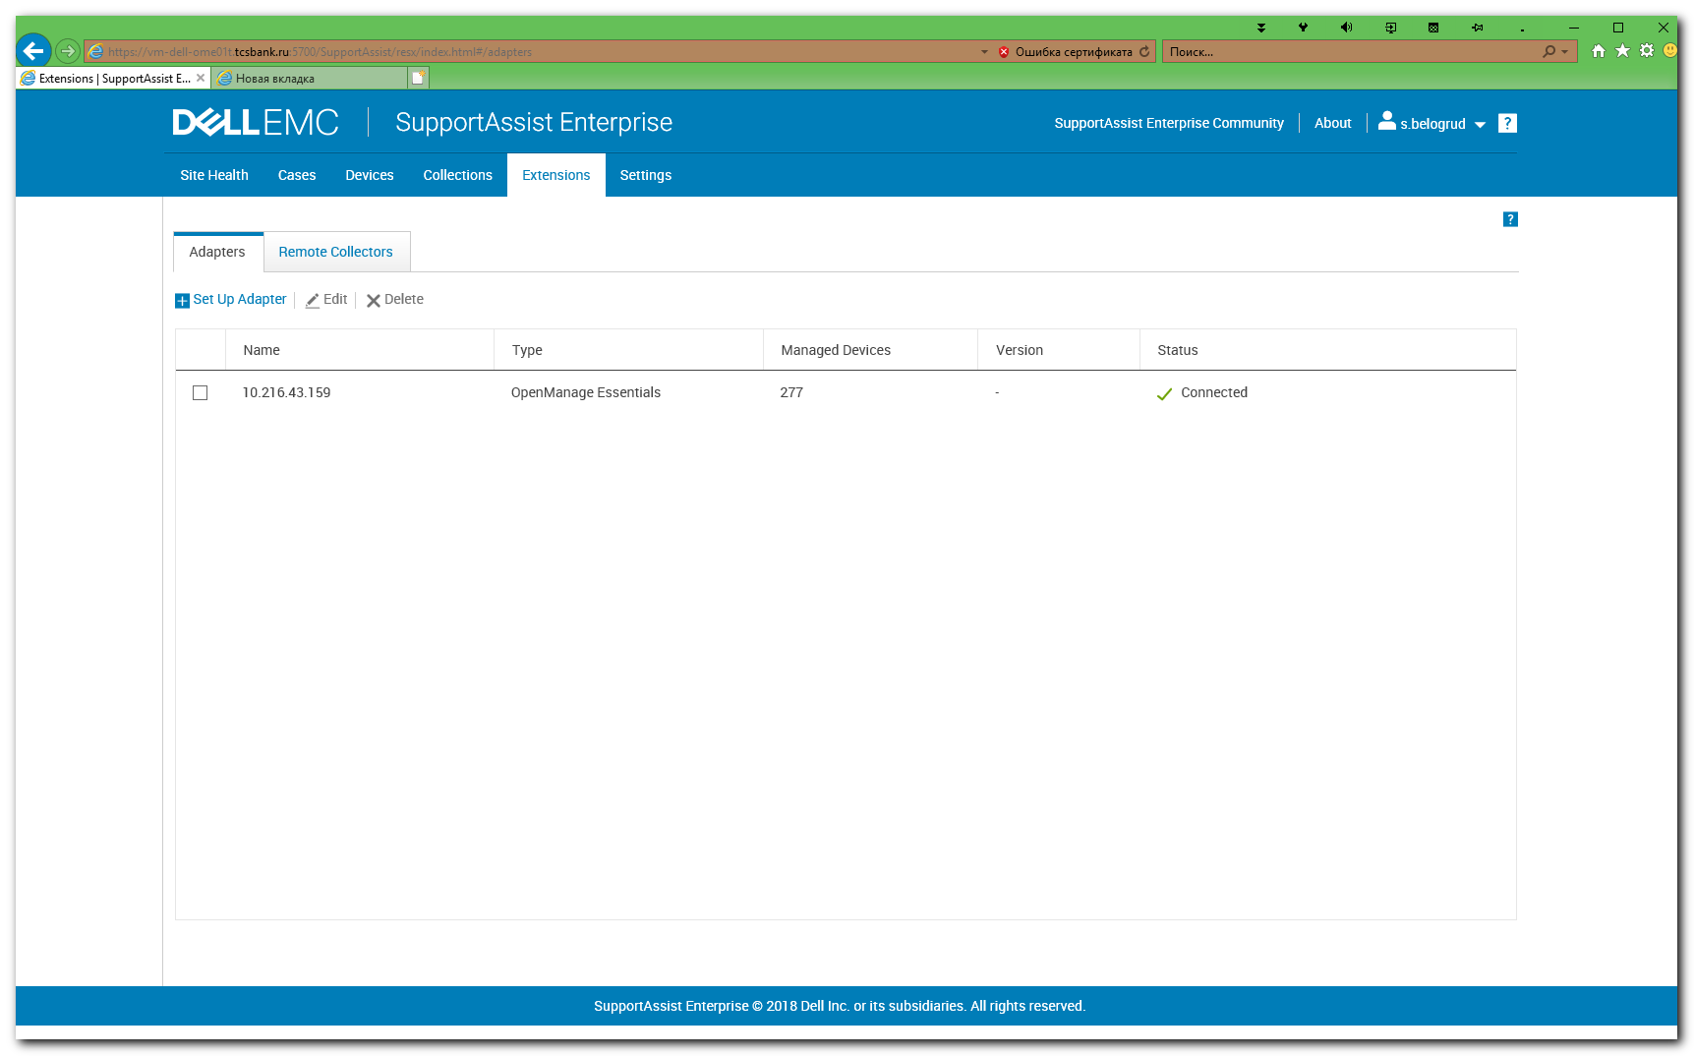

# Main window become looks like follow.
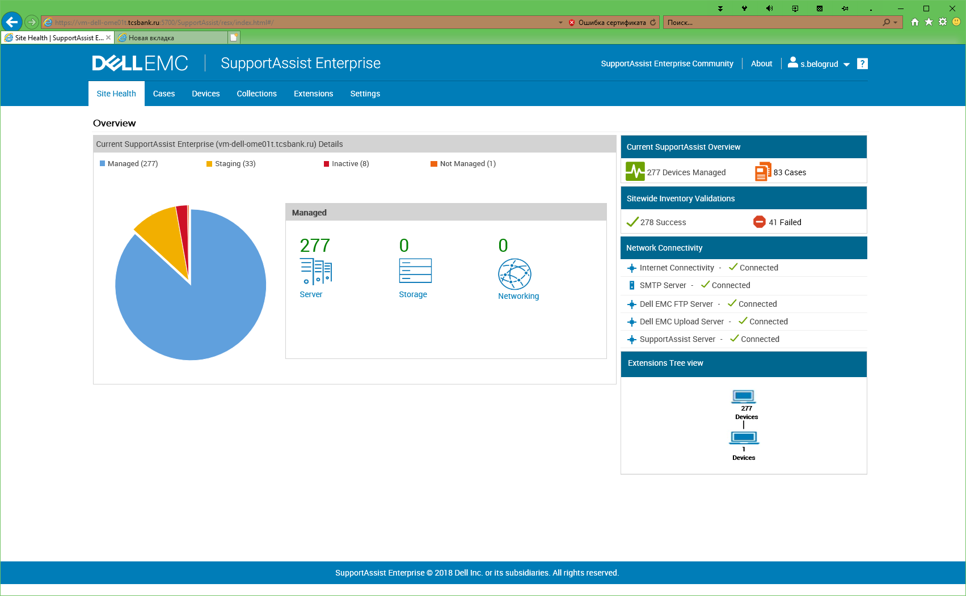

#
# But it was not too much long.
# After an half of hour or less the Adapter become again in not Connected state…
# Again I see this.
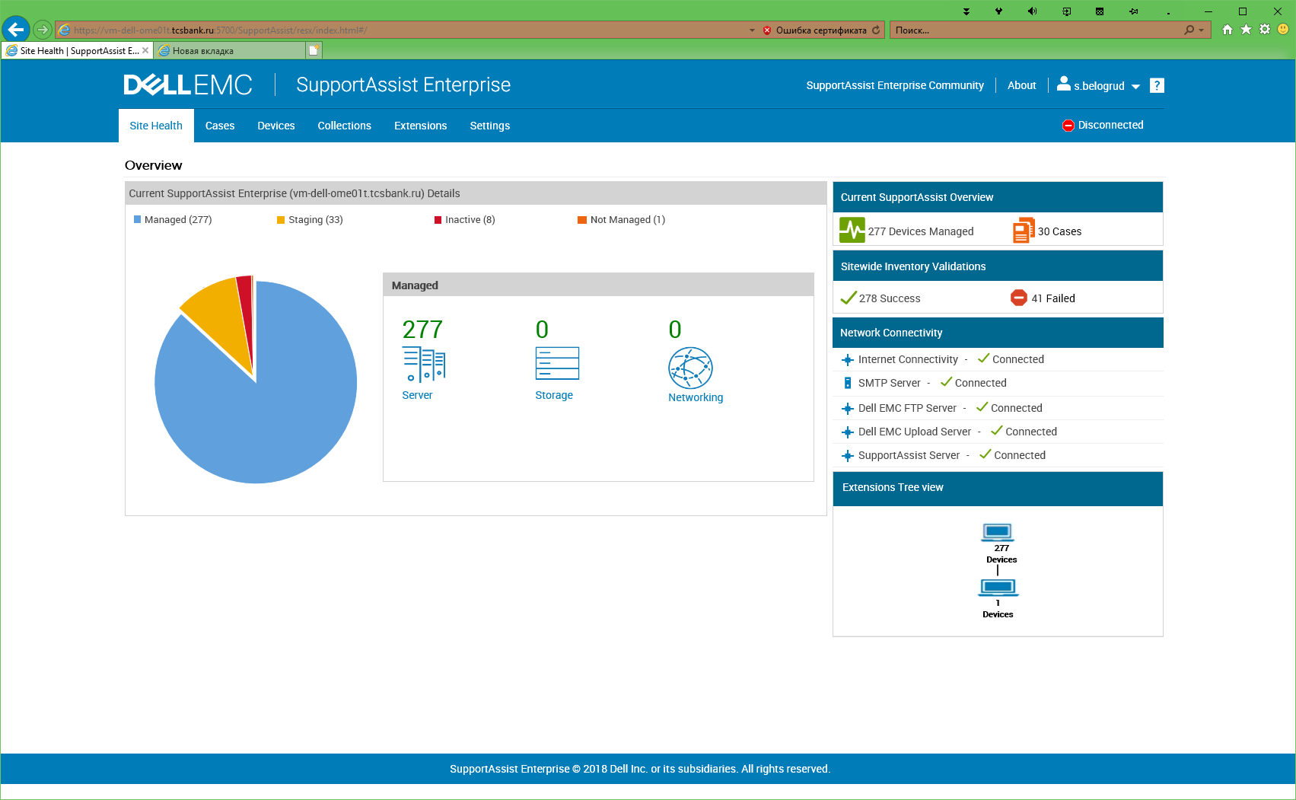

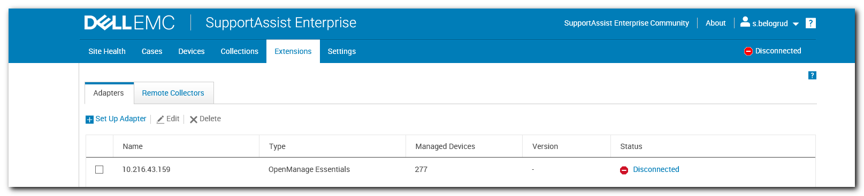

# In 11:51 the service was started successfuly.
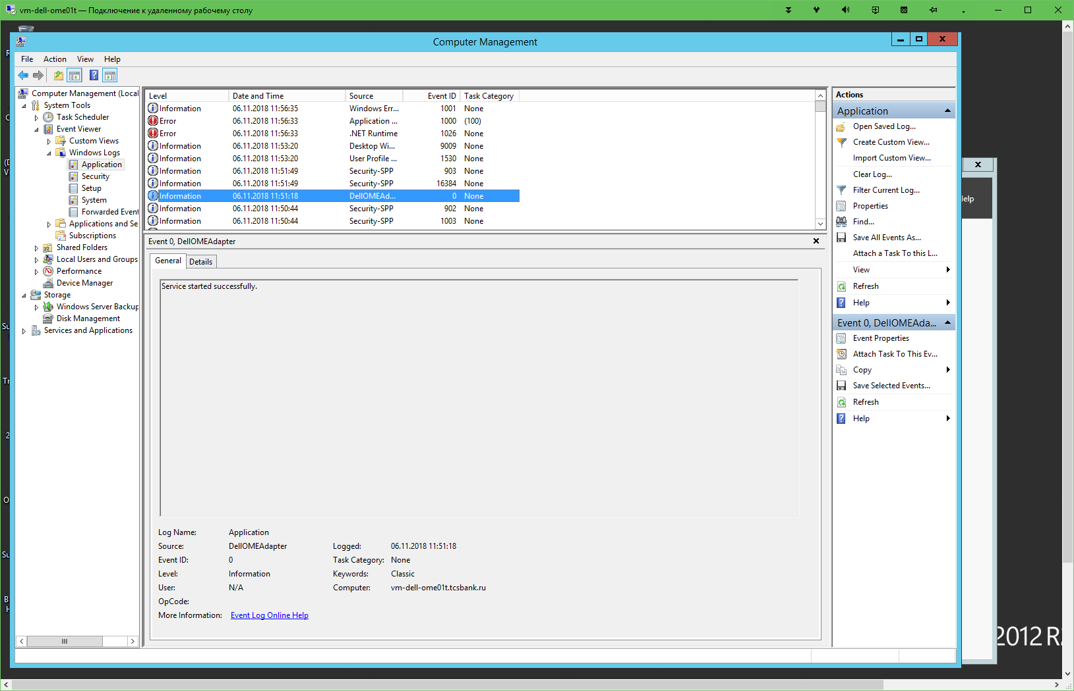

# But in 11:56 the service was stoped due to error.
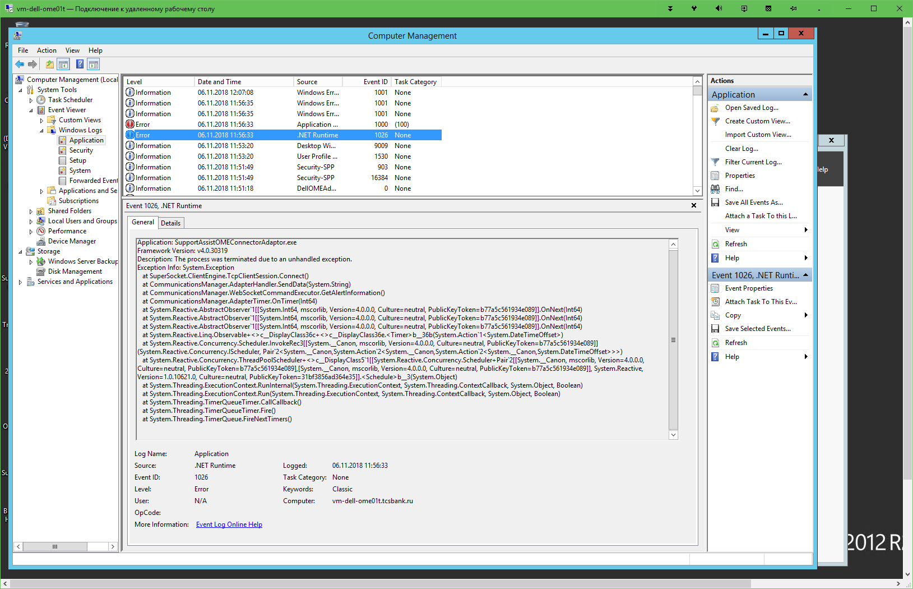
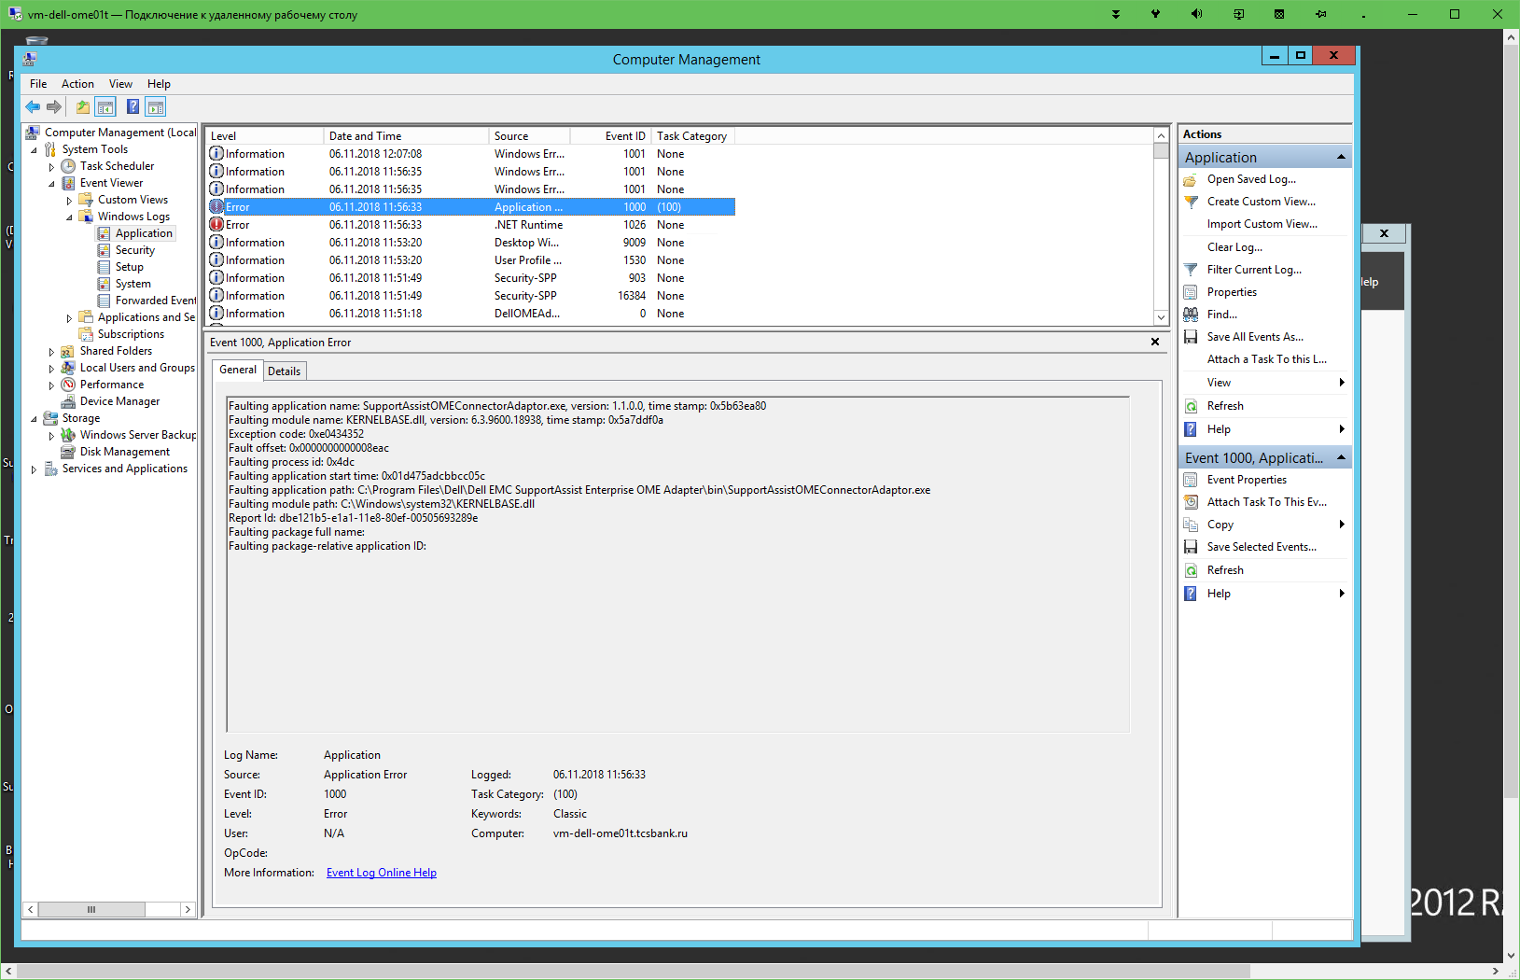
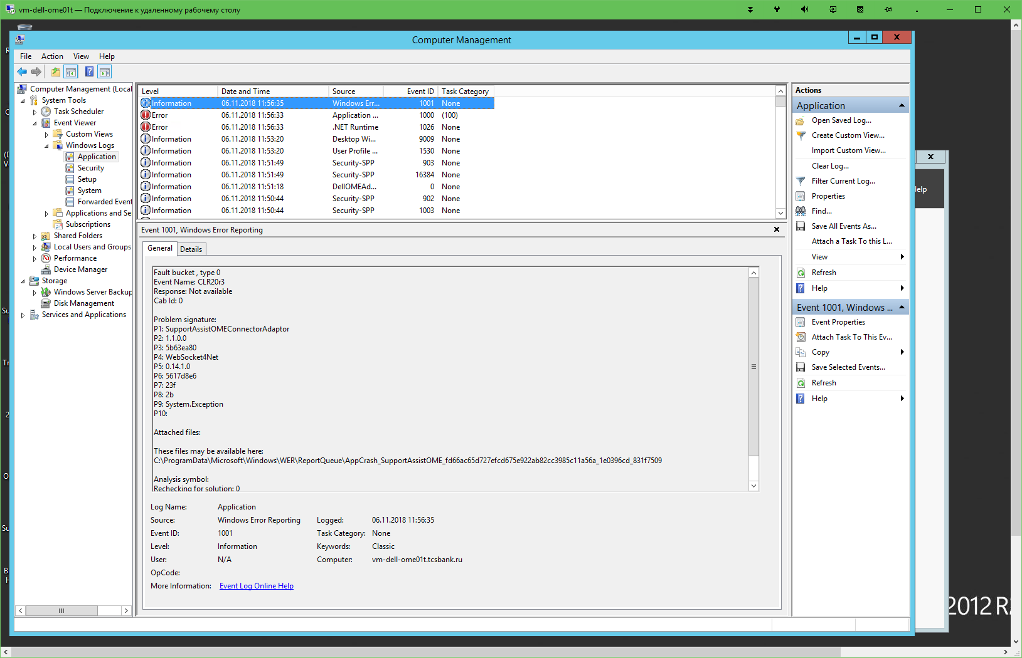

# Again, I ‘ve tried to start the service.
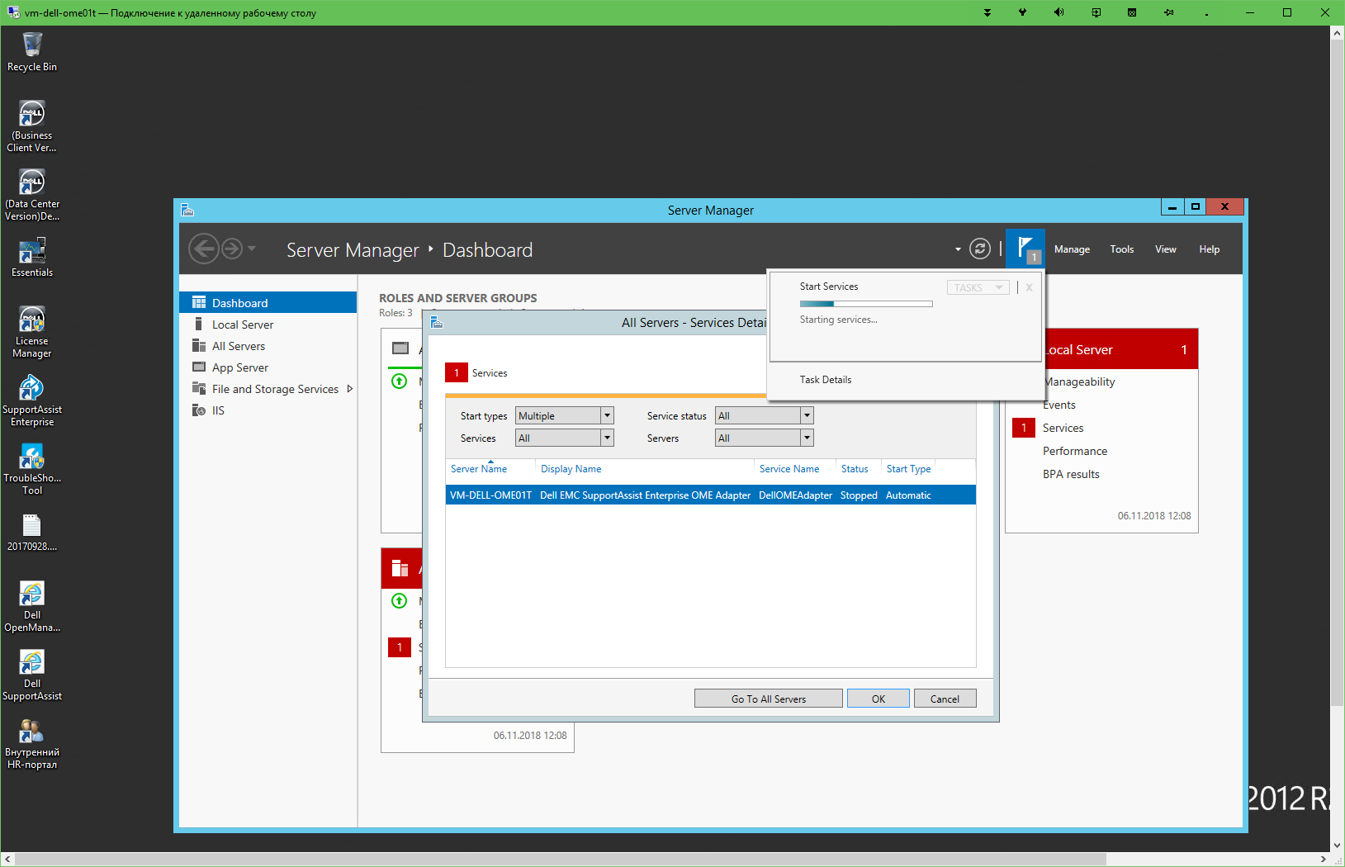

#
# Several emails was received, when I had restarted the service.
